# Experiment-1.2

## Student Name: Nabha Varshney UID: 20BCS4995

**Branch: CSE Section/Group: 20BCS-DM-704 (A)**

## Semester: 6th Date of Performance: 17th Feb 2023 Subject Name: Data Mining Subject Code: 20CSP- 351

**Aim** - To perform the statistical analysis of data.

## Objective-

* To perform statistical analysis like mean, median, standard deviation, min, max etc. after reading the data frame from stored file in system.

**Script and Output-**

library("RWeka")

N = read.arff("Data.arff")

print(N)

print(head(N,2))

print(tail(N,2))

dim(N)

names(N)

N["name"]

max(N["height"])

min(height)

sum(height)

mean(height)

median(sort(height))

sd(height)

summary(N)

attributes(N)

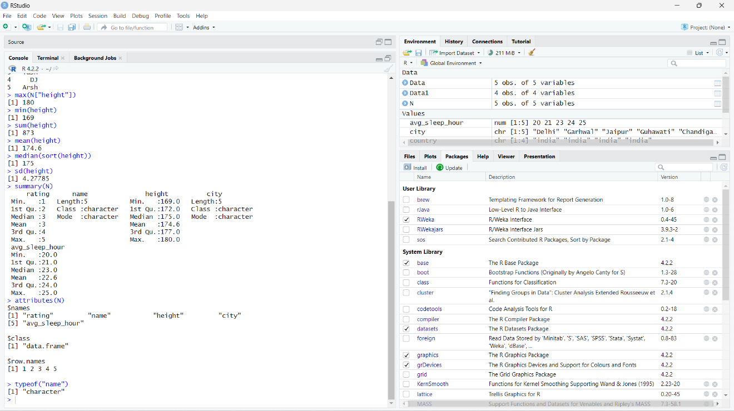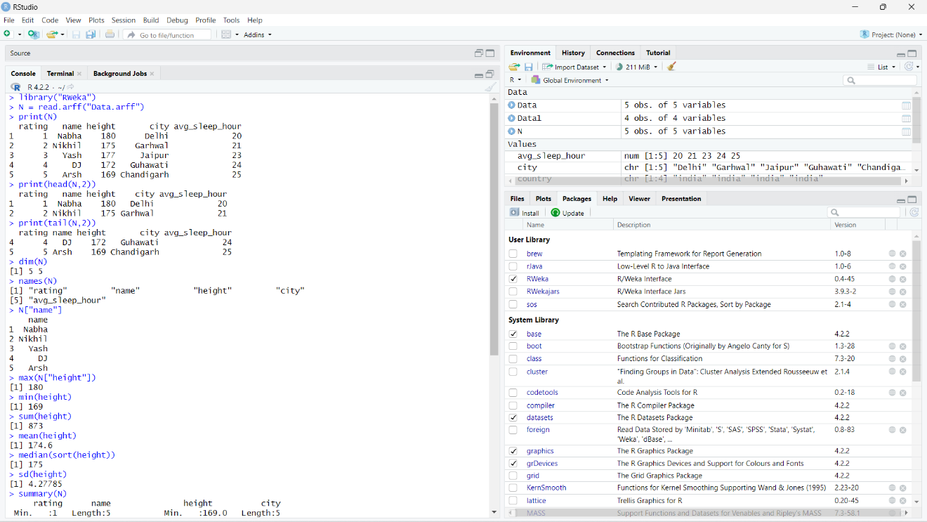typeof("name")